Code

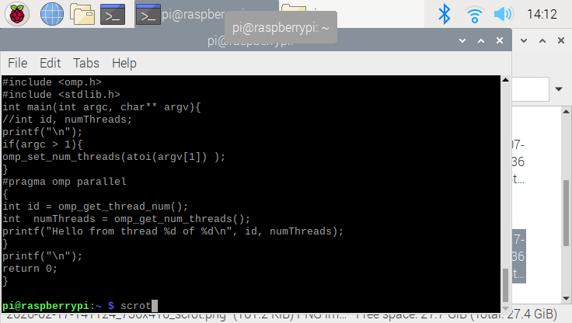

The code for this report is directly from the instruction pdf. This code will divide the tasks to individual cores, so that the computer could run efficiently. Since raspberry pi (B+) does have the 4 cores in CPU, the result of this code will be given 4 output. In order to understand this code properly , it need the basic knowledge on “omp.h” library, but for simplification, the computer would printout thread id , and number of threads. The id will give us a unique number(if we do properly), and the number of threads will be fixed .

Result

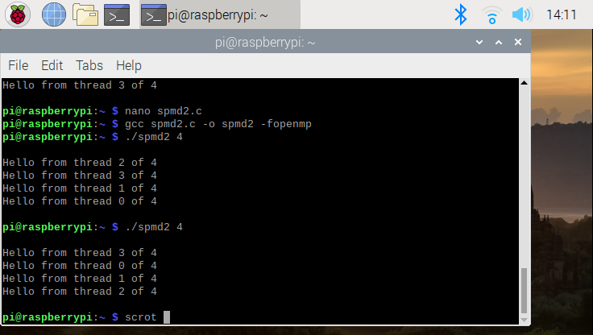

AS you could see, the code have 4 output. The main reason why this happen is because the CPU have 4 cores. Individual cores will take the tasks, and printout the number of threads. As you could realize, the all threads are unique, which we know they we are using the thread efficiently. The program is written in c language, and we must use the c compiler to run this program..